Investor centre is not opening
Remove Prajapati Magnum Head Title
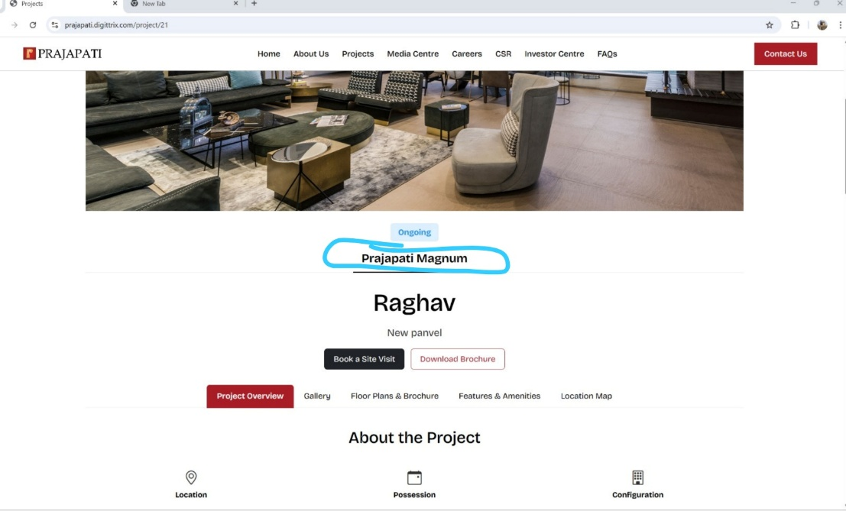
Count down and scrolling clarification
Vertical middle alignment
